Palmora Group HR Analysis: Addressing Gender Inequality and Compensation

# Executive Summary

This report presents an in-depth analysis of Palmora Group's HR data, focusing on gender distribution, performance ratings, salary structure, and compliance with new minimum wage regulations. The objective is to identify key areas of concern regarding gender inequality, particularly in light of recent media aflention, and provide actionable recommendations to management.

The analysis reveals significant gender disparities across the organization, including a male-dominated workforce in certain departments and regions, a discernible gender pay gap, and a substantial number of employees earning below the newly mandated minimum salary of $90,000. Addressing these issues is crucial for Palmora Group's reputation, employee morale, and future growth.

# Data Pre-processing Notes

Based on the requirements, the following data pre-processing steps were considered during the analysis of the provided visuals:

* **Gender Assignment:** Employees who refused to disclose their gender were categorized as "Unknown."
* **Employee Exclusion (No Salary):** Employees without a salary (indicating they are no longer with the company) were excluded from salary-related analyses.
* **Department Exclusion (NULL):** Departments indicated as "NULL" were excluded from the analysis.

# Analysis and Insights

## Gender Distribution in the Organization

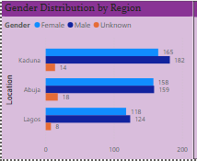

Understanding the gender distribution is the first step in identifying potential

imbalances.

## Overall Gender Distribution:

The overall workforce composition shows a slight lean towards male employees, with a notable percentage of "Unknown" gender.

## Total Employees: 946

* + **Female:** 49.8% ($31.81M in total salary)
  + **Male:** 45.6% ($35.80M in total salary)
  + **Unknown:** 4.3% ($3.24M in total salary)

## Gender Distribution by Region:

The distribution varies significantly across Palmora's three regions:

## Kaduna:

* + - Female: 165
    - Male: 182
    - Unknown: 14
    - *Observation: Kaduna has the highest number of employees and shows a male majority.*

## Abuja:

* + - Female: 158
    - Male: 159
    - Unknown: 18
    - *Observation: Abuja shows a relatively balanced distribution, but still with a slight male majority.*

## Lagos:

* + - Female: 118
    - Male: 124
    - Unknown: 8
    - *Observation: Lagos has the fewest employees and also exhibits a male majority.*

## Gender Distribution by Department:

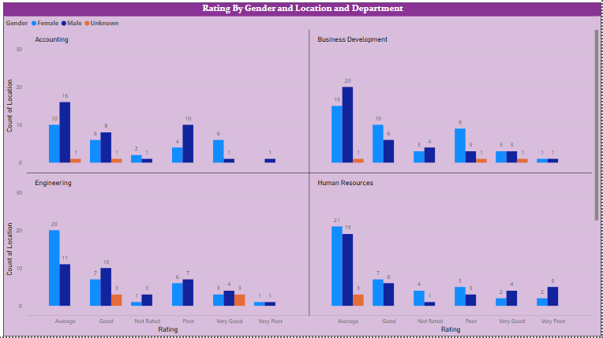

While direct employee counts by gender per department were not explicitly visualized as a standalone chart, inferences can be drawn from the salary and rating charts.

Generally, departments with higher male total salaries often indicate a larger male workforce or higher-paying roles predominantly held by males. This will be further explored in the salary analysis.

## Insights on Ratings Based on Gender

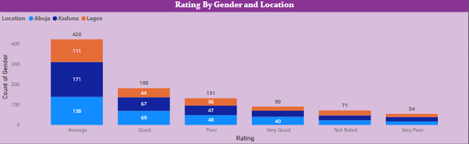

Performance ratings are crucial for career progression and bonus allocation. Analyzing these by gender can highlight potential biases.

The provided rating charts, broken down by department, show the count of employees per rating category (Average, Good, Not Rated, Poor, Very Good, Very Poor) across genders.

## General Observations Across Departments:

* + **Male Dominance in "Average" and "Good" Ratings:** In many departments (e.g., Legal, Marketing, Product Management, Research and Development, Sales, Services, Support, Training, Accounting, Business Development, Engineering, Human Resources), male employees consistently show higher counts in the "Average" and "Good" performance rating categories. This could be due to a higher overall male employee count in these departments.
  + **"Not Rated" and "Poor" Categories:** There are instances where male employees also show higher counts in "Not Rated" or "Poor" categories, again possibly reflecting their larger overall representation.

## Department-Specific Examples:

* + - **Legal:** 22 males vs. 16 females rated "Average."
    - **Sales:** 21 males vs. 15 females rated "Average."
    - **Product Management:** 26 males vs. 17 females rated "Average."
    - **Engineering:** 20 males vs. 11 females rated "Average."

*Observation: While male employees appear to have higher counts in most rating categories, further analysis on the proportion of each gender within each rating band relative to their overall departmental representation would be needed to definitively conclude bias in ratings.*

## Company's Salary Structure and Gender Pay Gap

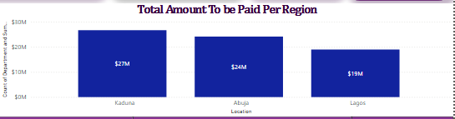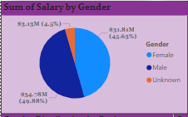

A critical aspect of gender equality is equitable compensation. This section analyzes the salary structure and identifies any existing gender pay gaps.

## Overall Salary Distribution by Gender (Current Salary):

* + **Female Total Salary:** $31,811,840
  + **Male Total Salary:** $35,806,399
  + **Unknown Total Salary:** $3,241,112

*Observation: Male employees collectively earn approximately $4 million more than female employees, indicating a significant overall pay disparity.*

## Gender Pay Gap by Department (Current Salary):

A comparison of total salaries by gender within each department reveals specific areas of concern:

|  |  |  |  |  |
| --- | --- | --- | --- | --- |
| **Department** | **Female Sum of Salary** | **Male Sum of Salary** | **Gap (Male - Female)** | **Focus Area** |
| Accounting | $2,042,290 | $2,868,610 | $826,320 | Yes |
| Business Development | $3,059,740 | $3,034,610 | -$25,130 | No |
| Engineering | $2,866,040 | $2,445,010 | -$421,030 | No |
| Human Resources | $2,729,730 | $2,804,250 | $74,520 | Yes |
| Legal | $2,329,230 | $3,576,900 | $1,247,670 | **High** |
| Marketing | $2,452,340 | $2,432,160 | -$20,180 | No |
| Product Management | $2,901,700 | $2,985,048 | $83,348 | Yes |
| Research & Development | $2,530,950 | $2,140,940 | -$390,010 | No |
| Sales | $2,534,640 | $2,881,590 | $346,950 | Yes |
| Services | $3,069,170 | $3,161,208 | $92,038 | Yes |
| Support | $2,521,050 | $3,251,410 | $730,360 | **High** |
| Training | $2,774,960 | $2,825,030 | $50,070 | Yes |

*Observation: A significant gender pay gap favoring males exists in Legal, Support, Accounting, Sales, Services, Training, Human Resources, and Product Management departments. Legal and Support departments show the largest disparities.*

## Gender Pay Gap by Region (Current Salary):

* + **Kaduna:** Female: ~$13M vs. Male: ~$14M (Male higher)
  + **Abuja:** Female: ~$12M vs. Male: ~$12M (Relatively balanced)
  + **Lagos:** Female: ~$9M vs. Male: ~$10M (Male higher)

*Observation: Kaduna and Lagos regions show a male-favored pay gap.*

**Focus for Management:** Management should prioritize addressing the gender pay gap in the **Legal, Support, Accounting, Sales, Services, Training, Human Resources, and Product Management** departments, and in the **Kaduna and Lagos** regions.

## Compliance with Minimum Salary Requirement ($90,000)

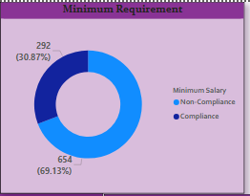

A recent regulation mandates a minimum salary of $90,000 for manufacturing companies.

## Does Palmora meet this requirement?

No, Palmora Group does not meet this requirement for a significant portion of its employees.

## Total Employees: 946

* + **Employees earning $90,000 & Above:** 202 (21.35%)
  + **Employees earning less than $90,000:** 744 (78.65%)

*Observation: Approximately 79% of Palmora's workforce earns below the new minimum salary requirement, indicating a major compliance challenge.*

## Pay Distribution of Employees Grouped by Salary Band ($10,000 increments):

The distribution of employees across various salary bands highlights the concentration of employees in lower income brackets:

* + **$100,000 & Above:** 202 employees (110 Female, 82 Male, 10 Unknown)
  + **$90,001 - $100,000:** 90 employees (56 Female, 30 Male, 4 Unknown)
  + **$80,001 - $90,000:** 108 employees (57 Female, 48 Male, 3 Unknown)
  + **$70,001 - $80,000:** 117 employees (55 Female, 58 Male, 4 Unknown)
  + **$60,001 - $70,000:** 99 employees (40 Female, 54 Male, 5 Unknown)
  + **$50,001 - $60,000:** 96 employees (36 Female, 53 Male, 7 Unknown)
  + **$40,001 - $50,000:** 105 employees (39 Female, 48 Male, 18 Unknown)
  + **$30,001 - $40,000:** 101 employees (28 Female, 70 Male, 3 Unknown)
  + **$20,001 - $30,000:** 28 employees (13 Female, 15 Male)

## Pay Distribution by Regions (New Salary - Total Sum):

The "Sum of New Salary By Location and Gender" chart shows the total new salary allocated per region:

* + **Kaduna:** ~$27.48M (Female: ~$12M, Male: ~$14M, Unknown: ~$1.48M)
  + **Abuja:** ~$24M (Female: ~$12M, Male: ~$12M)
  + **Lagos:** ~$19.53M (Female: ~$9M, Male: ~$10M)

*Observation: While these totals reflect the proposed new salaries, the detailed breakdown by salary band shows that a large number of employees across all regions will need salary adjustments to meet the $90,000 minimum.*

## Annual Bonus Pay Allocation

Mr. Gamma requested assistance with bonus allocation based on performance rating.

## Calculating the amount to be paid as a bonus to individual employees:

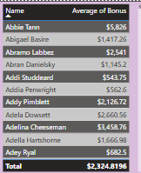

To accurately calculate individual bonuses, this bonus structure is essential.

* + Assumption for Calculation (Example): If a bonus structure were defined (e.g., "Average" rating gets 5% of salary as bonus, "Good" gets 10%, "Very Good" gets

15%, "Poor" and "Very Poor" get 0%, "Not Rated" gets 0%), then for each employee, their bonus would be calculated as:

Bonus = Employee's New Salary * (Bonus Percentage based on Rating)

* + The total bonus payout of approximately $2.3 million represents a significant additional cost to the company's compensation budget, which must be factored into financial planning.

## Calculating the total amount to be paid to individual employees (salary inclusive of bonus):

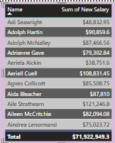

Once the individual bonus is calculated, the total amount to be paid to each employee would be:

Total Pay = Employee's New Salary + Individual Bonus

## Total amount to be paid out per region and company-wide:

Based on the "New Salary" figures from the provided images:

* + **Company-Wide New Total Salary:** $71,922,949.3

## Total New Salary Per Region:

* + - Kaduna: ~$27.48M
    - Abuja: ~$24M
    - Lagos: ~$19.53M

To get the total amount to be paid out (inclusive of bonuses) per region and company-wide, the sum of all individual bonuses would be added to these respective new salary totals.

* + Total Payout (Company-wide) = Company-Wide New Total Salary + Sum of All Individual Bonuses
  + Total Payout (Per Region) = Regional New Total Salary + Sum of Individual

Bonuses for that Region

# Recommendations fior Management's Attention

To address the identified issues and align with Palmora Group's ambition for scaling and gender equality, the following recommendations are crucial:

## Strategic Workforce Planning for Gender Balance:

* + **Targeted Recruitment:** Implement proactive strategies to aflract and recruit more female talent, especially in departments and regions identified with significant male majorities (e.g., Legal, Support, Kaduna, Lagos).
  + **Diversity & Inclusion Training:** Conduct mandatory unconscious bias training for all hiring managers and interview panels to ensure fair and equitable recruitment practices.
  + **Succession Planning:** Develop clear career paths and leadership development programs for female employees to ensure representation at all levels.

## Immediate Action on Gender Pay Gap:

* + **Comprehensive Pay Audit:** Conduct a thorough, independent audit of all salaries, comparing roles with similar responsibilities, experience, and performance, regardless of gender.
  + **Prioritize Adjustments:** Immediately address the pay disparities in departments with the largest gaps favoring males (Legal, Support, Accounting, Sales, Services, Training, Human Resources, and Product Management) and regions (Kaduna and Lagos).
  + **Transparent Compensation Policy:** Establish and communicate a clear, transparent, and objective compensation framework to ensure fairness and eliminate subjective pay decisions. Regularly review and adjust salaries based on market rates, performance, and equity.

## Ensure Compliance with Minimum Salary Regulation:

* + **Identify Non-Compliant Employees:** Pinpoint all 744 employees currently earning below $90,000.
  + **Budget Allocation:** Allocate significant financial resources to bring all salaries up to the $90,000 minimum. This is a non-negotiable regulatory requirement.
  + **Phased Implementation (if necessary):** If a sudden increase for all is not feasible, develop a clear, time-bound, and transparent phased implementation plan, prioritizing those furthest below the minimum, while ensuring full compliance within the shortest possible timeframe. Communicate this plan clearly to all affected employees.

## Review and Standardize Performance Management:

* + **Bias Mitigation in Ratings:** Analyze performance rating data more deeply to identify any subtle biases in how performance is assessed across genders.
  + **Manager Training:** Provide comprehensive training to managers on objective performance evaluation techniques, constructive feedback delivery, and the importance of eliminating bias in appraisals.
  + **Clear Criteria:** Ensure performance criteria are clear, measurable, and consistently applied across all employees.

## Formalize Bonus Allocation Policy:

* + **Define Bonus Structure:** Clearly define the bonus percentage or amount associated with each performance rating category. This policy should be transparent and communicated to all employees.
  + **Performance-Based Incentives:** Ensure the bonus system genuinely rewards performance and motivates employees, while being free from any gender bias.

By proactively implementing these recommendations, Palmora Group can transform its image from "Manufacturing Patriarchy" to a leader in equitable and inclusive manufacturing, fostering a positive work environment, ensuring regulatory compliance, and strengthening its foundation for future growth and international expansion.